Key Statistics and Graphs for C1

* Total sales amount: $66,848,505.78
* Total sales amount by region:

1 (North): $11,917,620.05

2 (South): $5,040,422.24

3 (East): $16,523,453.47

4 (West): $33,366,990.02

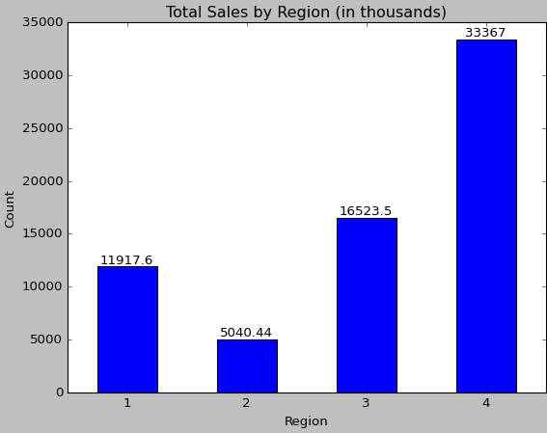

* Percentage breakdown of total sales amount by region:

1 (North): 17.83%

2 (South): 7.54%

3 (East): 24.72%

4 (West): 49.91%

Age group totals

|  |  |
| --- | --- |
| Age Groups | Total |
|  |  |
| 18-30 | 32,885 |
| 31-60 | 34,403 |
| 61-90 | 12,691 |

Percentage of age group totals

|  |  |
| --- | --- |
| Age Groups | Percentage (%) |
|  |  |
| 18-30 | 41.12 |
| 31-60 | 43.02 |
| 61-90 | 15.87 |

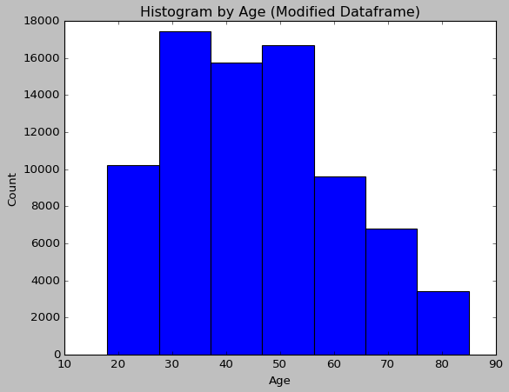

Percentage breakdown of age groups by region

|  |  |  |
| --- | --- | --- |
| Age Groups | Region | Percentage (%) |
|  |  |  |
| 18-30 | 1 | 21.79 |
|  | 2 | 13.26 |
|  | 3 | 21.53 |
|  | 4 | 43.42 |
|  |  |  |
| 31-60 | 1 | 19.66 |
|  | 2 | 22.33 |
|  | 3 | 24.35 |
|  | 4 | 33.66 |
|  |  |  |
| 61-90 | 1 | 19.66 |
|  | 2 | 62.67 |
|  | 3 | 20.04 |
|  | 4 | 1.01 |
|  |  |  |
|  |  |  |
|  |  |  |
|  |  |  |
|  |  |  |
|  |  |  |

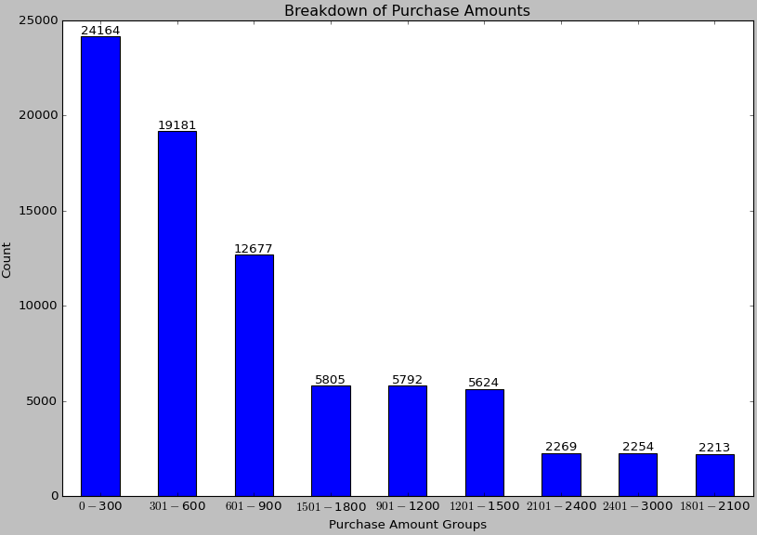

Purchase amount groups total

|  |  |  |
| --- | --- | --- |
| Purchase amount groups | Total |  |
|  |  |  |
| $0 - $300 | 24,164 |  |
| $301 - $600 | 19,181 |  |
| $601 - $900 | 12,677 |  |
| $901 - $1200 | 5792 |  |
| $1201 - $1500 | 5624 |  |
| $1501 - $1800 | 5805 |  |
| $1801 - $2100 | 2213 |  |
| $2101 - $2400 | 2269 |  |
| $2401 - $3000 | 2254 |  |
|  |  |  |
|  |  |  |
|  |  |  |
|  |  |  |
|  |  |  |
|  |  |  |

Percentage breakdown of purchase amount groups

|  |  |
| --- | --- |
| Purchase amount groups | Percentage (%) |
|  |  |
| $0 - $300 | 30.21 |
| $301 - $600 | 23.98 |
| $601 - $900 | 15.85 |
| $901 - $1200 | 7.24 |
| $1201 - $1500 | 7.03 |
| $1501 - $1800 | 7.26 |
| $1801 - $2100 | 2.77 |
| $2101 - $2400 | 2.84 |
| $2401 - $3000 | 2.82 |

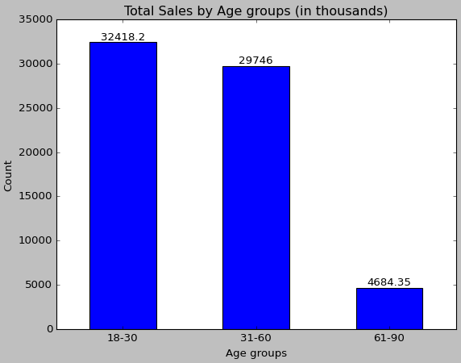

BIG IDEA: eCommerce has huge potential!

Blackwell Electronics eCommerce website, after just one year, shows incredible progress!

Exactly 50% of all purchases last year were online, which means customers are eager to interact with the eCommerce website. To put that into perspective, that means 39,989 out of 79,979 purchases were online. Just imagine how much more activity there can be in the eCommerce website as time goes on!

More specifically, eCommerce seems most popular in the South region, which accounts for 50% of all online purchases. In fact, the South region is not associated with any in-store purchases. The West region had the same number of online purchases as in-store purchases. The East region had more in-store purchases than online purchases. The North region had no online purchases and made up 40% of in-store purchases.

Most importantly, online purchases accounted for about 53.70% of total sales last year. In contrast, in-store purchases accounted for about 46.30% of total sales. This clearly shows that customers

Online

BIG IDEA: